Designing a Google Classroom

Teaching instructors in middle and high school on how to implement a Google Classroom.

By: Debbye Lasky, David Cripe, Michael Lipnicky, and Kara Yarc
Spring 2017
ISLT 9471

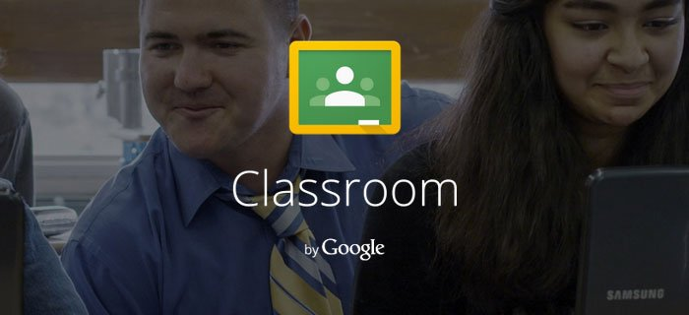

Project Roles and Responsibilities
Debbye Lasky | - Project Manager  - Submit project requirements in Canvas on behalf of team  - Contribute and/or design the presentation  - Broad Goals and Big Ideas  - Formative Evaluation  - Contextual Analysis  - Implementation Plan  - Appendix & References contributor
David Cripe | - Contributor to all portions of project, as needed  - Task Analysis  - Summative Evaluation  - Materials for Training Program  - Implementation Plan  - Appendix & References contributor
Michael Lipnicky | - Contributor on all portions of project, as needed  - Needs Analysis  - Summative Evaluation  - Types of Learning Experiences and/or Instruction  - Implementation Plan  - Appendix & References contributor
Kara Yarc | - Contributor to all portions of project, as needed  - Create outline for project on google docs  - Learning Objectives  - Formative Evaluations  - Learner Analysis  - Implementation Plan  - Appendix & References contributor

Executive Summary
In this Instructional Plan we designed a course for a one day training opportunity for teachers of secondary grade levels (6-12). The main goal of the plan is to prepare teachers that have not used Google Classroom before to use the tool productively in their classroom. This plan should allow for anyone experienced with the tool to be able to use this base plan to complete a training for staff at most school districts.

Table of Contents
Executive Summary 2
Table of Contents 3
SECTION 1: DESIRED RESULTS 5
Broad Goals and Big Ideas 5
Learning Objectives 6
Needs Analysis 6
Task Analysis 8
SECTION 2: EVIDENCE OF ACCEPTABLE RESULTS 11
Formative Evaluation 11
Summative Evaluation 12
End of Course Evaluation 12
Post Course Evaluation 12
SECTION 3: LEARNING EXPERIENCES AND/OR INSTRUCTION 14
Learner Analysis 14
Contextual Analysis 14
Types of Learning Experiences and/or Instruction 17
Learning Objective 17
Type of Learning 17
Instructional Strategy 17
Rationale 17
Materials for Training Program or Learning System 18
Implementation Plan for Product (Schedule and Logistics) 18
References 20
Appendix A 21
Needs Analysis 21
Online Delivered Survey 21
Focus Group: Target Learners 22
Focus Group: Students of Learners 23
Interviews: Building Level Administrators 24
Task Analysis 25
Procedural Flowcharts 25
Access Google Classroom: 25
Join a classroom: 26
Classroom Creation: 27
Classroom Activities: 28
Formative Evaluation 28
Areas of Focus During Observation 28
Teacher Survey 28
Summative Evaluation 29
After Completion Survey 29
Appendix B 33
Sample Training Materials 33
Overview of Accessing Google Classroom Presentation 33
Implementation Plan 36

SECTION 1: DESIRED RESULTS

Broad Goals and Big Ideas

Due to the drastic changes in available technology over the last decade many standards of how to deliver instruction in the classroom have changed. In today’s era of teaching and learning it is now possible to deliver instruction to students you never meet. With that in mind it is important that we equip teachers, at all levels, on methods of delivering instruction in these new ways, both to prepare them for the changes coming to their own classrooms, and so that they can prepare their students for the changes in how they will receive instruction during their lifetime. This course will focus on demonstrating google classroom to secondary teachers. We have chosen this tool specifically as a starting point for preparing teachers and students for blended learning environments that have become increasingly popular in high schools across the country.

The teachers will be presented with benefits of using google classroom with students, as well as the drawbacks to be aware of. The course will strive to motivate the secondary teachers to create a google classroom in order to increase positive online interactions and feedback with students. The course will cover topics within google classroom, such as, online grading, assignment submission, online discussions, attaching videos, documents and other media files, as well as setting up multiple classrooms.

It is our goal to provide teachers with the type of instruction that will lead them to design a google classroom that utilizes the teachers prior knowledge, prior experiences, but more importantly, blends with” real world situations.” The course will provide teachers the skills needed to set up classes and add their own materials to the site. The course will facilitate a deeper understanding of the content knowledge. Course instruction will be delivered via an in-service, professional development style, that will provide teachers the guidance to ensure all participants are comfortable and confident using Google Classroom to meet their teaching needs. We anticipate our training will meet the following goals:

Goal 1: Teachers will be able to access Google Classroom.

Goal 2: Teachers will be able to use posting features in Google Classroom.

Goal 3: Teachers will know why to use Google Classroom.

Learning Objectives
The following learning objectives were developed to align our learning plan needs to the goals of the design:

Goal 1: Teachers will be able to access Google Classroom.
1.1 Following a demonstration, the secondary teachers will be able to create classes in Google Classroom with 100% accuracy.

1.2 Following a Power Point lesson, the secondary teachers will set up a google classroom, by following instructions and sharing link to join classroom with presenters.

Goal 2: Teachers will be able to use posting features in Google Classroom.

2.1 Following a demonstration and lesson, the secondary teachers will be able to upload resources to Google Classroom with 100% accuracy.

2.2 Following a lesson with examples, the secondary teachers will include 3 google classroom features to their newly developed google classroom by choosing features that would personal classroom resources from their class and present their google classroom site to class without assistance.

Goal 3: Teachers will know why to use Google Classroom.

3.1 Following a lesson with examples, the secondary teachers will identify at least 5 benefits of using a google classroom by playing an interactive round of Kahoot during presentation.

3.2 Following a lesson with examples, the secondary teachers will identify at least 2 situations where using a google classroom is not beneficial by playing an interactive round of Kahoot during presentation.

Needs Analysis

The needs assessment for this course will need to establish the prior knowledge level of the learners. Because the learners will be primarily made up of educators that are currently working in classrooms their backgrounds will vary based on technology exposure, the types of subjects they teach, as well as the age of the children that they teach. This variance will also affect their perceived needs from this course, and need to be identified in this assessment process. We selected the methods and order of data collection to try to ensure the most accurate data is collected, as well as to use methods that would ensure more comfort with the process for the learners involved.

To be successful the needs analysis will need to identify what current state of learning management system use is, establish the feelings of the target learners in regards to using a learning management system, ensure that the administration and building leaders support the growth of the staff in this direction, and to identify the specific needs that should be met to enable the training to be successful.

To complete the needs analysis, we will use the following methods:

- Online Survey to ascertain prior experience with google products, as well as to get initial details about what tools and issues they experience in their classrooms. Using the results of this survey will allow us to better target questions during the focus groups. This survey should also inform us of any high level issues we will face with implementation after the training. Delivering this survey online also allows us to identify early in our planning if there are issues with basic computer usage by tracking the results of the survey coming in with who we send the survey to. By following up with survey respondents that do not respond we may be able to find and assist prospective learners that have computer usage deficiencies before the workshop occurs. The instrument for this survey is located in appendix A.

- Focus groups with target learners to verify the findings of the survey, as well as to gain feedback on what the learners think they know about the material using more open ended questions, as well as being able to follow up on trends from the online survey. When forming the group we will be careful to insure that we include learners from different grade levels and subjects, both core and elective based to get as much varied feedback as possible. The starting questions for this focus group will concentrate on the comfort level of the learners with what the tool can do in their room and establish us with information about the motivation level of the learners. Additional questions should be added if time allows based on trends from the survey. The instrument for this focus group is located in appendix A.

- Focus groups with students from target classrooms to determine the needs of the students our learners will be working with after the course. When forming this group we will again try to group the members from various backgrounds to try to avoid missing needs during the assessment. The questions used during this focus group establish if there are any equity issues of access at home for blended learning, and then gathers expectations from our learners end “customers” to ensure that our goals will line up with the end needs for the learning experience. The instrument for this focus group is located in appendix A.

- One on one interviews with building level administrators to determine any roadblocks to implementation for the learners after the course. This phase of the needs analysis serves not only to ensure that the stated objectives of the course are aligned with the learners needs, but also to ensure that they will be able to use the course after completion. The interviews will also allow us to have and verify that we did not miss any significant subgroups in our previous focus groups. These interviews although last in the order of delivery are very important as the building level administrators are key to successful implementation after the training, without their support usage levels may not increase the way that we would expect. It is key during this interview to gauge the interest level of the administrator during the interview. The instrument for these interviews are located in appendix A.

Task Analysis

Prerequisite Analysis:

A survey will be administered to learners beforehand to determine the level of experience that they have regarding Google Apps and Google Classroom. The survey that will be used is the same as the summative assessment survey that will be used to assess the learners at the end of the course. This will allow learners to be divided into different groups based on their level of experience and confidence in using Google Apps and Google Classroom. The target group size will be no more than 10 learners per group. The ability levels of the learners will determine if there are any goal areas that can be accelerated or skipped during the delivery of the instruction.

Topic Analysis:

Goal 1: Teachers will be able to access Google Classroom.
- Introduction to Google Classroom
  - Access Google Classroom
    - To achieve this goal learners will need to be able to demonstrate that they can navigate to the google classroom website, and use credentials to log into the service.
- Learners will be able to properly name a classroom and section.
- Learners will be able to find and distribute join codes, or email invitations, and know which method is most appropriate for their situation.

Goal 2: Teachers will be able to use posting features in Google Classroom.

- Put Comments on shared documents or ask for Comments (to learn the feature)
- Place announcements into the stream.

Goal 3: Teachers will know why to use Google Classroom.

- Teachers will need to know why to use the product as it is not always an appropriate tool.
- Teachers will need to know how to evaluate when to use the tool.
- Teachers will need to know what situations google classroom is not appropriate for.

Procedural Analysis:

Using an instructivist approach to the task analysis we identified numerous tasks and decisions that need to be made while using the google classroom tool. We broke the tasks down into major usage areas:

- Accessing Google Classroom
- Joining a Classroom
- Creating a Classroom
- Classroom Activities

Each of these areas was then mapped out to identify where information would be needed, and what decisions would have to be made to compete tasks inside the system.
The first area we identified as a major component of using the tool was knowing how to access the tool, and what credentials to use to access the tool. This process map is named Access Google Classroom in appendix A. As noted in the process map, after gaining access to the tool there are 3 main areas where deeper processes existed.

Classroom creation, outlined in appendix A as Classroom Creation, requires data to create the class (Name, Section, and Subject). It also requires the user to make choices based on if they are using the tool by themselves, or as a group of instructors, and how they will add students to the class after it is created.

There was an additional method to creating classrooms, and adding students that could be done with data automation tools, but we decided that it was outside the scope of this training course due to the resources it would require. If a learner’s organization were to use that method for creating and joining students to classrooms, it would bypass those sub-processes outlined here.

Some of the processes required are simple to complete, such as joining a classroom with a code (Join a classroom, appendix A). Others are more complex, Classroom Activities (Classroom activities, appendix A) for example has more decisions due to the extra options available while using the tool.

These decisions will be some most frequent skills that will need to be used by the learners after completing this course, as they will be the day to day usage decisions and processes that our learners will have to navigate while using google classroom.

Using google classroom will require access to the following resources:

- Electronic devices (Tablets, Chromebooks, PC’s, Mac’s, or Phones) for the teacher and students
- Internet access anywhere use is required

Google classroom as tool is very flexible about the platform required to use it. There are app’s available on all form factors, which platform is best will depend on available resources such as available Wi-Fi, computer lab access, home access to internet. As well as personal preferences of the user.

To be successful with this tool in addition to learning the tool itself the user would need to be comfortable using the device they access the tool through, be willing to work in an environment that changes from time to time outside of their control, Google product updates can sometimes be disruptive to classrooms. They will also require a working knowledge of the rest of the Google Apps Suite of tools (Drive, Docs, Sheets, YouTube, Calendar, Presentations, Forms) as all of these tools are used in conjunction with classroom to create a dynamic environment.

SECTION 2: EVIDENCE OF ACCEPTABLE RESULTS

Formative Evaluation
The formative evaluation will take place during the development of the Google Classroom informational training session in order to identify potential areas of weakness. A select group of secondary-level teachers from varying subjects will be asked to view the presentation, explore the training materials, and complete the activities.

Approaches to Gain Information:

Focus Group: A group of secondary teachers from a variety of subjects will be selected to complete a mock version of the training session. Teachers will view the training materials and access Google Classroom. They will also complete the instructional activities. Observing teachers performing these tasks will allow for data collection on teacher mastery of using Google Classroom as well as utilizing at least two posting features. The data collected will be utilized to make the necessary revisions, upgrades, or modifications.

Key Questions
1. Can teachers navigate to Google Classroom?
2. Can teachers upload documents to Google Classroom?
3. Can teachers successfully utilize Google Classroom for storing and organizing their classroom activities and assignments?
4. Is the content in the instructional materials accurate and helpful to teachers?
5. How much time does the training require and is it appropriate?
6. Do teachers feel the training session is beneficial?

Prior to Training: Data Collection of focus group information will ensure teachers will have adequate time time to learn about and begin creating a Google Classroom. It will also show general areas of strengths and weaknesses in teacher’s ability to access and use Google Classroom and it’s features. Additionally, a teacher survey will be administered to the focus group of teachers after the focus group training session is complete. Administering the survey immediately following the conclusion of the mock training session will allow for a more reliable and valid evaluation from the involved teachers. Responses from teachers will aid in improving the training materials before the actual session takes place.

Teacher Survey: A teacher survey will be administered to our pilot group, post-training session. Administering the survey directly following the conclusion of the training session will allow for valid and reliable evaluations from the teachers in the mock training session. Responses from the teachers will help ensure our training materials will work for the actual training session.

See Formative Evaluation instruments in Appendix A

Summative Evaluation

End of Course Evaluation
The end of course evaluation will be Project based. This method was chosen do to the goal of getting teachers to use the product after the class is completed. For this project the teachers in the class will create a Google Classroom Class, invite both the instructor and at least two other learners. They will also participate in at least two of their fellow learners classes to simulate running a full google classroom. The project will be graded using the following rubric:

Criteria | Points Available | Totals
Contains 3 postings (1 point per posting) | 3
Responded to at least 2 Postings (1 point per posting) | 2
Classroom has an Announcement (1 point for announcement) | 1
Classroom has joined students (1 point for single joined student, 2 for more than one) | 2
Classroom is named properly (point only awarded if the room is named properly) | 1
Classroom is allowing interactivity (point only awarded if commenting is enabled for students) | 1
Totals: | 10

Post Course Evaluation

To monitor the success of the learners after the completion of the learning experience we will use multiple methods to ensure that the training was successful and achieved its goals. One of the methods will be to use the tools built in to Google’s G Suite to monitor the usage of the applications that were included in the learning experience. The other method that we will use to monitor the success of our learning experience will be to use a survey of the staff that uses a mix of questions that included open ended responses giving opportunity for feedback on the usefulness of the tool, and to determine if follow-up learning opportunities are needed.

- Method 1: Survey

A survey to explore how well the course knowledge was retained was developed and is attached in appendix A. This survey will be sent out at the end of the training session to be completed within 5 days of the course to judge how well the instruction was retained immediately following the training.

- Method 2: gSuite Reports

In order to judge the rise of new useage of the classroom tool we will monitor the district's reporting area for reports about usage of the tool. The two main reporting areas we will watch are the Active Classroom report, the other is Post created report.

Using the Active classes report we can get an accurate count of how many different classes are using the tool. To measure success with our training we are hoping to see the average number of active classes increase by 20% in the weeks following the training. Below is a sample of the graph available in the report.
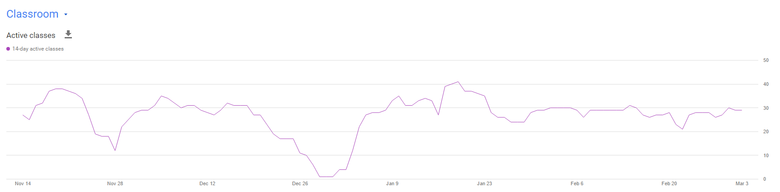

The second part of our ongoing monitoring will be the Posts created report that will show us how interactive the classrooms that are active are being. This report shows not just that the class is active but also is it the teachers, or the students, or both that are making posts to the classroom. By allowing us to look into how the tool is being used it will allow for us to design follow-up trainings that address shortfalls in implementation that we are tracking. For example in the sample chart below you can see that students are not being engaged for feedback much at all in the system, which is a key part of what this tool can do for your classroom. In this metric we are looking for student posting to be as large if not larger than staff posting to show good engagement with the students.
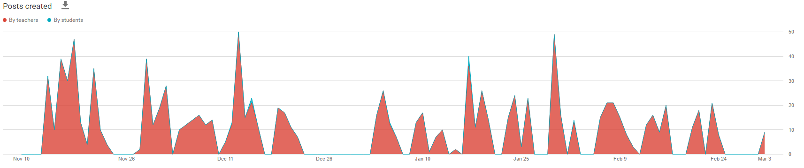

By combining these two reports with the survey done at the end of the training day we should be able to determine if the training met the needs of the staff both immediately following the training to see that we covered what was needed, and as time passes after training by monitoring the tools usage and seeing if and how the staff puts the tool into practice in their classrooms. This addresses two levels of Kirkpatrick's Training evaluation model, both behavioral change, as well as reactions to the training.

SECTION 3: LEARNING EXPERIENCES AND/OR INSTRUCTION

Learner Analysis
Our Google Classroom presentation will be targeting middle school and high school teachers. We will have to gather information that allows ways to best communicate and instruct these specific individuals and allows for them to continue to develop their Google Classroom site on their own. We will be gathering information regarding the following:

1. Our learners’ educational demographics,
2. Our learners’ background in technology,
3. Our learners’ classroom technology access, type, and availability,
4. Our learners’ internet access and availability,
5. Our learners’ time availability for the project, and
6. Our learners’ willingness to commit to this project.

Contextual Analysis
The Google Classroom program provides teachers with one technology which is designed to enhance the learning experience. Classroom provides productivity tools such as electronic messaging and document distribution and organization for teachers and students. The tools provided allow for collaboration in real-time and the ability to work remotely. We will hold an initial telephone interview with administration to find some information and then email a questionnaire for the teachers to complete. In this interview and questionnaire, we will be covering the following questions:

Orienting Context | Means of Data Collection
Learner Factors
Demographics:  - Who are our learners - teachers, paras, coaches?  - What are their ages?  - What are their years of experience in the classroom?  - What is their primary language?  Goal Setting:  - Have the teachers used Google Classroom before?  - What do the teachers want to learn?  - What are their primary questions with regard to online hosting classroom resources?  - What are their primary issues with regard to Google Classroom?  - What are they most comfortable with when it comes to online hosting of teacher resources? | Telephone interview with Administration  Teacher Needs Assessment Questionnaire
Immediate Environment Factors
Access:  - Do the teachers currently have a Google account?  - Are the teachers willing to set up a Google account?  - Do all teachers have internet access?  - Do all teachers have access to computers? | Teacher Needs Assessment Questionnaire and Telephone interview with Administration
Organizational Factors
Budget and Time:  - What is the available budget for this training program?  - How much time will we have for the initial presentation?  - Will additional trainings be required? | Telephone Interview with Administration

Instructional Context | Means of Data Collection
Learner Factors
Skills:  - Are teachers comfortable setting up a Google Classroom?  - Have the teachers been using an online classroom site like Blackboard or Canvas? If so, to what extent?  - Have the teachers been to training regarding Google Classroom? | Teacher Needs Assessment Questionnaire
Immediate Environment Factors
Access:  - Can the teachers access Google Classroom on the school’s system?  - Are computers available for training?  - Is there a separate room for training? | Telephone Interview with Administration
Organizational Factors
Technical Supports:  - Will school technical staff be available to help if necessary?  - Who will be responsible for ensuring all teachers have access to Google? | Telephone Interview with Administration

Transfer Context | Means for Data Collection
Learner Factors
Commitment:  - Are teachers willing to invest the time to develop their Google Classroom? | Teacher Needs Assessment Questionnaire
Immediate Environment Factors
Opportunities:  - Will administration allow time for teachers to work on their Google Classroom site development at work? | Telephone Interview with Administration
Organizational Factors
Ongoing Support:  - Is the district technology department familiar with Google Classroom?  - Will instructors be allowed to return if questions arise? | Telephone Interview with Administration

Assumptions:
Because we will not have actual teachers and administrators to participate in our focus group to complete surveys and interviews, the following assumptions will be made so that we can complete our assignment:
- All teachers have Google accounts.
- All teachers are willing to invest time to create a Google Classroom.
- All teachers have access to computers and the internet.
- Computers will be available during training.
- Our training program will be given four-hours for our presentation.
- We will be allowed to return, should problems or questions arise.

Types of Learning Experiences and/or Instruction
The method of delivering this training is live instructor led, it allows for largest amount of support for learners while working through the course. The instruction should be delivered in a room with high amounts of technology access, either through a laptop cart, or computer lab environment. If the learners have access to a BYOD style program that also will suit the needs of the learning if the equipment as internet access.

During the instruction delivery, generally the instructor will deliver presentations with Live demos at the end of each presentation, allowing for a question period. Details for each topic are in the following table aligned to the goals of the training:

Learning Objective | Type of Learning | Instructional Strategy | Rationale
Goal 1: Teachers will be able to access Google Classroom.
1.1 Following a demonstration, the secondary teachers will be able to create classes in Google Classroom | remember | Stimulate recall of prior learning | During this lesson the teachers will be shown how to log in and the basics of creating a classroom. The goal allows us to establish baselines of everyone’s ability in the class.
1.2 Following a Power Point lesson, the secondary teachers will set up a google classroom | Application | Elicit Performance | This lesson builds on the previous lesson allowing us to bring the teachers to a point where they can do the work of making a classroom on their own.
Goal 2: Teachers will be able to use posting features in Google Classroom.
2.1 Following a demonstration and lesson, the secondary teachers will be able to upload resources to Google Classroom | Understand | Provide Guidance | In this lesson we show the teachers how to bring resources to google classroom, and then talk to when and why to bring each type of resource.
2.2 Following a lesson with examples, the secondary teachers will include 3 google classroom features to their newly developed google classroom | Apply | Elicit Performance | This lesson builds off of 2.1 in that teachers during this lesson will apply what they learned in the previous lesson.
Goal 3: Teachers will know why to use Google Classroom.
3.1 Following a lesson with examples, the secondary teachers will identify at least 5 benefits of using a google classroom | remember | Gain Attention | During this lesson more information about what the tool can do for you when you use it will be covered.
3.2 Following a lesson with examples, the secondary teachers will identify at least 2 situations where using a google classroom is not beneficial. | evaluate | Elicit Performance | In this lesson more examples of use will be cover, and discussions about about scenario’s will be had.

Materials for Training Program or Learning System
Sample Materials were created which include a Presentation for the start of the instruction on accessing Google Classroom. This presentation is attached with instructor notes in appendix B, and can be used as a presentation tool, as well as a handout, which can be given to the learners either with or without the instructor notes attached.

Another Sample material that was created was a central hub site that will be used as a central reference place to organize materials for the instructor, and as a reference site for the learners during and after the completion of the training. This site will also contain supplemental materials for the learners who want more information or need more scaffolding than the direct instruction can provide. Screenshots of this tool are also in appendix B.

Implementation Plan for Product (Schedule and Logistics)
This course is designed to be delivered in a 4 hour window, with 2 hours of direct instruction, and then 2 hours of available build time for the learners to put what was learned into immediate practice. This allows for two groups of learners to complete the training in a day in any given lab environment. As noted in the contextual analysis we will have the following facilities needs: Access to a computer lab type room, the room will be needed for half a day at a time. We will have the following IT needs: Logon access to the computers in the lab environment, internet access, and valid, active google accounts for the learners in the session, we will also need a support person available for any username/password problems, or hardware faults. Handouts will be provided electronically for all learners, however some hard copies will need to be made for learners that are not equipped for paperless distribution.

Instruction will be split into one hour segments, with 5 minute breaks between sessions. Time to complete labs will be padded with extra time in case of any malfunctions with equipment, and to allow for breaks for the learners.

Budgetarily this training will have varied impact depending on when it is delivered. If delivered during an inservice day costs will be minimal as no substitutes will be needed, and the trainers are existing staff that do not require outside pay. Costs should be contained in this fashion to building operational costs, and the costs of any printed handouts that are required. All other resources for this course carry no costs.

If however the training is provided during summer, regular class day, or outside of normal operating hours, other costs could arise. These costs include but are not limited to: Per Diems, Substitute costs, cleaning staff costs.

A sample half day schedule has been included in Appendix B.

References
Cradler, J. (n.d.). Implementing Technology in Education: Recent Findings from Research and Evaluation Studies. Retrieved from http://neuage.org/portfolio/SilverDrive/more/implementingTechnology.htm

Frazier, M & Hearrington, D. (2017). Technology Coordinator’s Handbook Third Edition. Portland: International Society for Technology in Education. ISBN# 9781564843883

Google for Education: Empower your educators to transform student learning. (n.d.). Retrieved April 13, 2017, Retrieved from https://edu.google.com/training/

Larson, M. & Lockee, B. (2014). Streamlined ID: A Practical Guide to Instructional Design. New York: Routledge. ISBN#: 9780415505185

Appendix A

Needs Analysis

Online Delivered Survey

Introduction:
Please complete this survey as completely as possible, the results of this survey are being used to design instruction for a workshop on Google Classroom usage to enable blended and online learning options for the future. Your open and honest responses will help guide the design and delivery of this workshop. Thank you for your input at this critical juncture. All information submitted in this survey will be kept confidential to the design team, and will only be shared as aggregate data when required.

Questions:

Please Select the types of technology available in your classroom (Select all that apply):
- Interactive Whiteboard
- Projector
- Student Devices to share
- Student Devices 1 to 1
- Teacher Laptop
- Teacher Desktop
- Printer
- Digital Camera
- Wireless Access

If you selected student devices, please note the type here (Select all that apply):
- iPad
- Android Tablet
- Chromebook
- Kindle
- Windows Tablet
- Windows Laptop
- BYOD Mix
- Cell Phones

Have you taken any online courses?
- Yes
- No

If so please describe any issues you had during the course: (short answer response)

Have you ever delivered an online course?
- Yes
- No

If so please describe any issues you had during the course: (short answer response)

Have you ever used online collaboration tools?
- Yes
- No

If so please describe any issues you had using them: (short answer response)

How do you currently track assignments in your courses? (short answer response)

Do your students have internet access available outside of class?
- Yes
- No

Do you have any students that require adaptations when using computers?
- Yes
- No

If Yes, please detail the adaptation, without any personally identifiable information.
(Short Answer Response)

Focus Group: Target Learners
Request for Attendance:
We are inviting you to attend a focus group in room ___ at (Insert Time). You have been identified by our group as a representative of a group of learners we are designing a training for, while not mandatory your attendance would greatly enhance our design for our upcoming training workshop. We do not anticipate this focus group taking very long, as we know that everyone has limited available time. Please RSVP to us using the calendar invite that was sent in conjunction with this message.

Questions for the Group:

How do you feel about technology in the classroom?

Do you feel adequately supported with technology in the classroom? Please explain.

What do you know about Google as a company? What do you know about their products for Education?

How do you feel about the idea of paperless classrooms?

Please tell us about any concerns you have about using online collaboration tools in your classroom.

Focus Group: Students of Learners
Request for Attendance:

Staff we are conducting a focus group with students that you teach, please send down the following students from your room during ___ Period.
(Student List).
We will have them for the entire period. Please let us know if there are any conflicts we need to accommodate. Thank you in advance!

Questions for the Group:

Do you have access to internet at home? If so what device or devices do you have access on?

Do you know of anyone that doesn’t have internet at home?

Play short video that shows google classroom to the students.
Link: https://youtu.be/nxaZlsdC2Do

Do you think it would be easier or harder to stay organized if your teacher used google classroom?

Are there any concerns about using a tool like this in your classes?

How would you feel if your teachers used this tool to hold you accountable to complete your work on time?

Interviews: Building Level Administrators

Questions:
- What are the major initiatives coming up for the next year?
- Are their any accommodations that would need to be made for your students using an online learning system to complete and turn in work without paper?
- How do you see this tool changing the classroom environment in your building?
- When do you need staff ready to use the tool?
- What do you need them to be able to do with it?
- Are there any “roadblocks” we need to be aware of?
- Who are our learners - teachers, paras, coaches?
- What are their ages?
- What are their years of experience in the classroom?
- What is their primary language?
- Do all teachers have internet access?
- Do all teachers have access to computers?
- Will administration allow time for teachers to work on their Google Classroom site at work?
- What is the available budget for this training program?
- How much time will we have for the initial presentation?
- Will additional trainings be required?
- Can the teachers access Google on the school’s system?
- Are computers available for training?
- Is there a separate room for training?
- Will school technical staff be available to help if necessary?
- Is the district technology department familiar with Google and Google’s educational resources?
- Will instructors be allowed to return if questions arise?

Task Analysis

Procedural Flowcharts

Access Google Classroom:
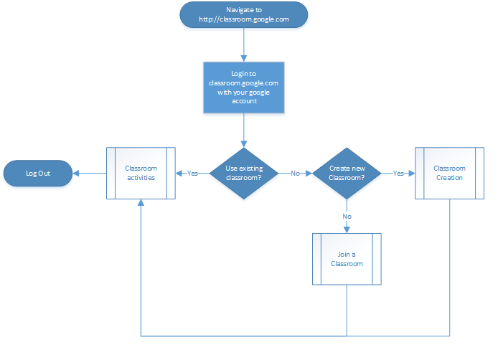

Join a classroom:
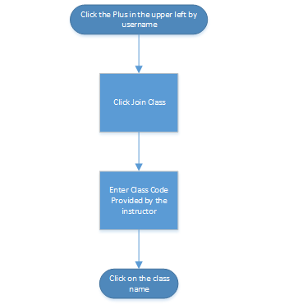

Classroom Creation:
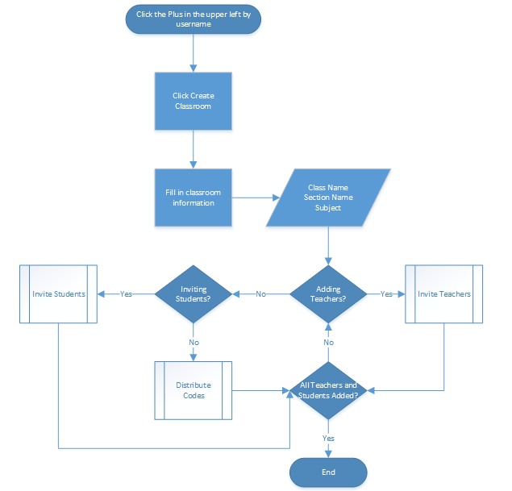

Classroom Activities:
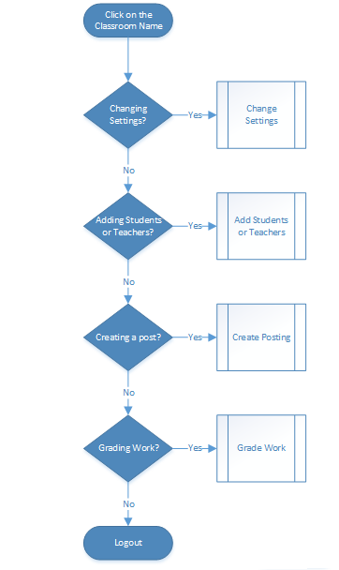

Formative Evaluation

Areas of Focus During Observation
1. Ease of navigation to Google Classroom.
2. Ease of ability to upload resources to Google Classroom.
3. Success of using at least two posting features within Google Classroom.
4. Time of training
5. Accuracy of training

Teacher Survey
This survey is designed to gather timely feedback from your participation in the focus group for Designing a Google Classroom instructional training session. Your responses will help aid in improving the quality of the future teacher training session.

1. Do you currently use an online hosting site for your classroom materials?
○ Yes ○ No

2. How would you rate your level of experience with online hosting sites, like Google Classroom, before the training session?
○ None ○ Very Little ○ Moderate ○ High ○ Very High

3. How would you rate your level of experience with online hosting sites, like Google Classroom, after the training session?
○ None ○ Very Little ○ Moderate ○ High ○ Very High

4. Before the training session, did you ever use Google Classroom?
○ Yes ○ No

5. How easy was it for you to navigate to the Google Classroom website?
○ Very Easy ○ Easy ○ Moderate ○ Difficult ○ Very Difficult

6. How easy was it to upload your resources to Google Classroom?
○ Very Easy ○ Easy ○ Moderate ○ Difficult ○ Very Difficult

7. Was the content in the instructional materials accurate?
○ Very Accurate ○ Accurate ○ Moderate ○ Inaccurate ○ Very Inaccurate

8. How helpful were the instructional materials?
○ Very Helpful ○ Helpful ○ Moderate ○ Useless ○ Very Useless

9. How beneficial was the training session?
○ Very Beneficial ○ Beneficial ○ Moderate ○ Useless ○ Very Useless

10. Please add any relevant information or comments.

Summative Evaluation

After Completion Survey

1. How can students join a Classroom class? (Select all that apply.)
- By asking their teacher
- By joining using a class code
- By accepting a teacher’s invitation
- By searching the class name

2. Teachers can invite their students to join their class by sending them a message from:
- The Gmail Compose button
- A shared Google document
- Google Calendar events
- The Student section in Classroom

3. If teachers don’t have Classroom available as a choice but want to communicate at scale with their students, they can:
- Send individual emails
- Ask their students to sign up for Classroom themselves
- Share a Google Group
- Create Contact groups to easily send emails and share documents

4. With Classroom, you can: (Select all that apply.)
- Upload class materials
- Assign and collect student work
- Send announcements to your class
- Record online classes

5. In Classroom, you can add the following to your assignment:
- Files
- Links
- Different due dates for each student
- Videos

6. If I don’t want my students to modify a worksheet in a shared folder, I can:
- Ask them to use mobile devices
- Share the folder as view-only
- Give them edit permissions
- Use Hangouts to share it

7. When adding a Drive document to a Classroom assignment, you have the following options: (Select all that apply)
- Make a view-only file for each student
- Students can edit file
- Make a copy for each student
- Students can view file

8. Where are assignment documents created in Classroom stored?
- Google Drive
- Google Groups
- The student’s device
- Google Safe Search

9. Students must turn in a document in Classroom in order to complete an assignment.
True or False

10. If a teacher creates a shared folder with a student, each file in that folder:
- Can be accessed by the teacher
- Has to be individually shared by the student for the teacher to view
- Is invisible to the teacher
- Can only be in Google Docs format

11. Teachers can view how many students have turned in their work in Classroom.
True or False
12. Students can turn in these kinds of files in Classroom assignments: (Select all that apply.)
- Videos
- Google Sheets
- Google Docs
- Images

13. Once students turn in their assignments in Classroom, teachers cannot provide further feedback.
True or False

14. These tools help teachers give feedback to students: (Select all that apply.)
- Forms
- Docs
- Research Tool
- Classroom

15. Forms used in G Suite for Education can’t remain anonymous.
True or False

16. Two ways to provide feedback in Docs are:
- Revision history
- Comments
- Headers and footers
- Suggested edits

17. One way to use Google Classroom to flip your classroom is by:
- Creating duplicates of documents for each student
- Sending individual messages to students
- Creating rosters with Google Groups
- Sharing videos and readings as announcements in the Classroom stream for students to view prior to coming to class

18. A teacher wants her students to provide honest but constructive feedback to their peers regarding their performance in a theater production rehearsal. If this was her goal, why would the teacher have unchecked some of the Form Settings options below?
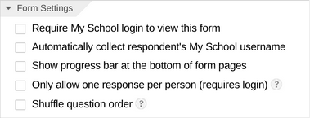
- Questions are shuffled
- They can’t share it
- Responses are kept anonymous
- Each student receives the answers

19. An educator, who uses Classroom, had her students do an outside Science project with their tablet. She could create an ___________ in Classroom to gather their work in an organized way.
20. If you want to recommend modest corrections to a student’s work (such as adding a comma) but do not want to directly edit the document, you could take advantage of this feature in Docs:
- Suggested edits
- Revision history
- Add-ons
- Public sharing

21. A fellow educator wants to start using Classroom, but is worried he will need to post material five times because he teaches five units of the same class. You mention that he should click on _________ to assign multiple classes.
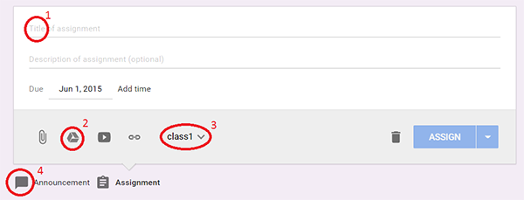
- 1
- 2
- 3
- 4

22. You want to add a student to your Classroom period. If you cannot send the student an email invite because Gmail is restricted for your school’s domain, how can you register them?
- Requesting your administrator to add him/her
- Inputting his/her name into the Student tab
- Sharing a unique class code
- Sharing a Google Doc

Appendix B

Sample Training Materials

Overview of Accessing Google Classroom Presentation

Slide 1
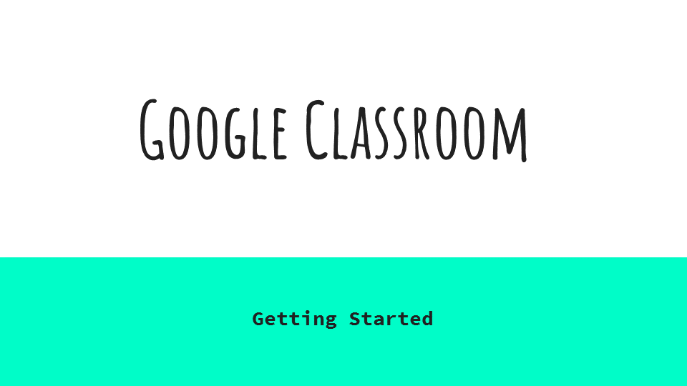

Slide 2
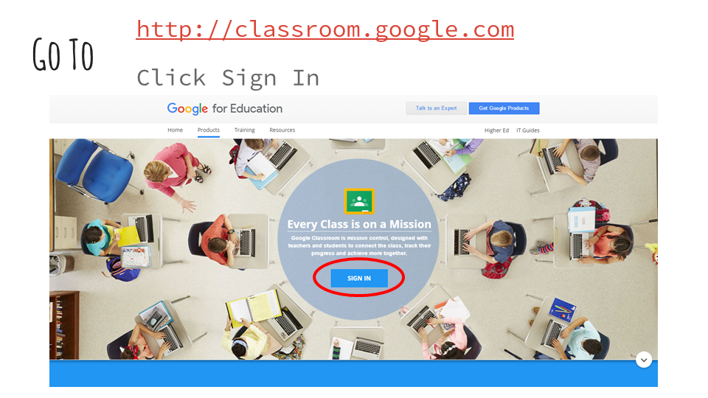
Notes:

Sign in with your credentials that you use for school. DO NOT USE PERSONAL CREDENTIALS. The sign in button on this page can move around from time to time as google updates their pages.
Slide 3
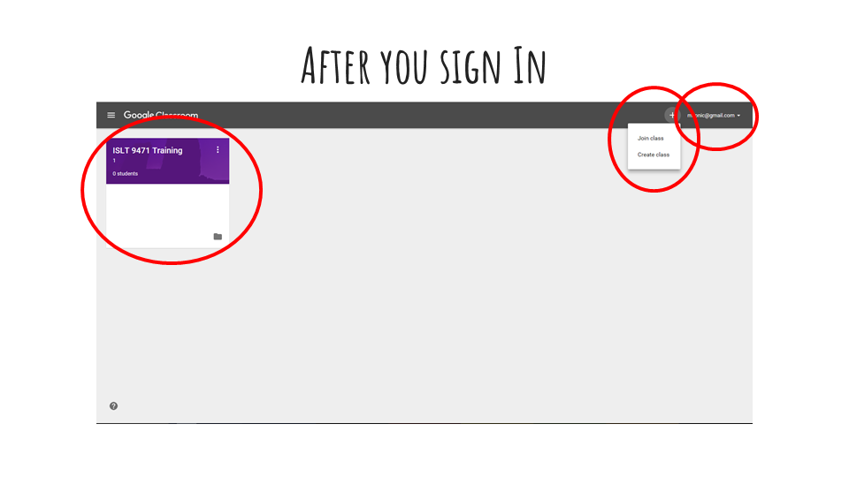
Notes:

Class tiles: Classes line up, and as a teacher it shows how many students are in the section. The text has the course name the second line is the section name.
Plus Button: Lets you Join a class or make a new class
To join a class you need a “Join Code”
To Make a class you will be asked for the course name, section name and description.
Username in left corner: Helps you know who is signed in.
Hub Website:
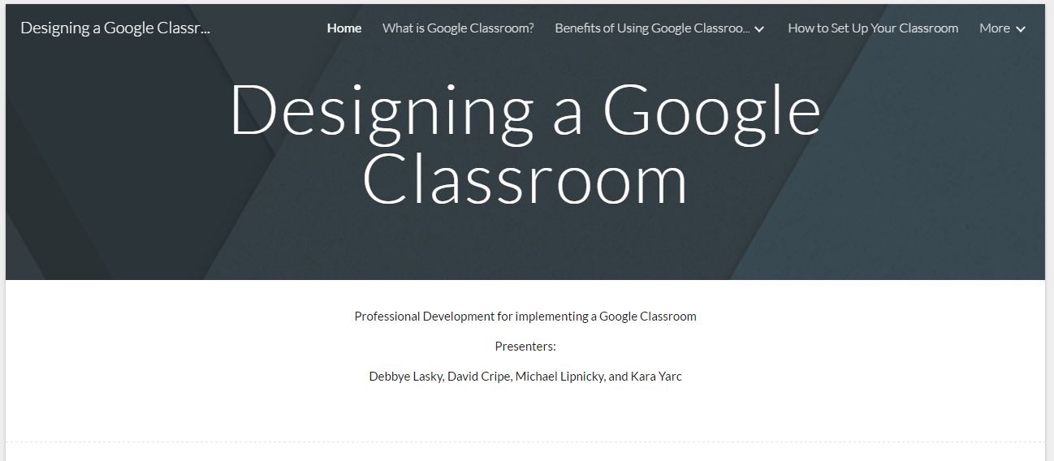

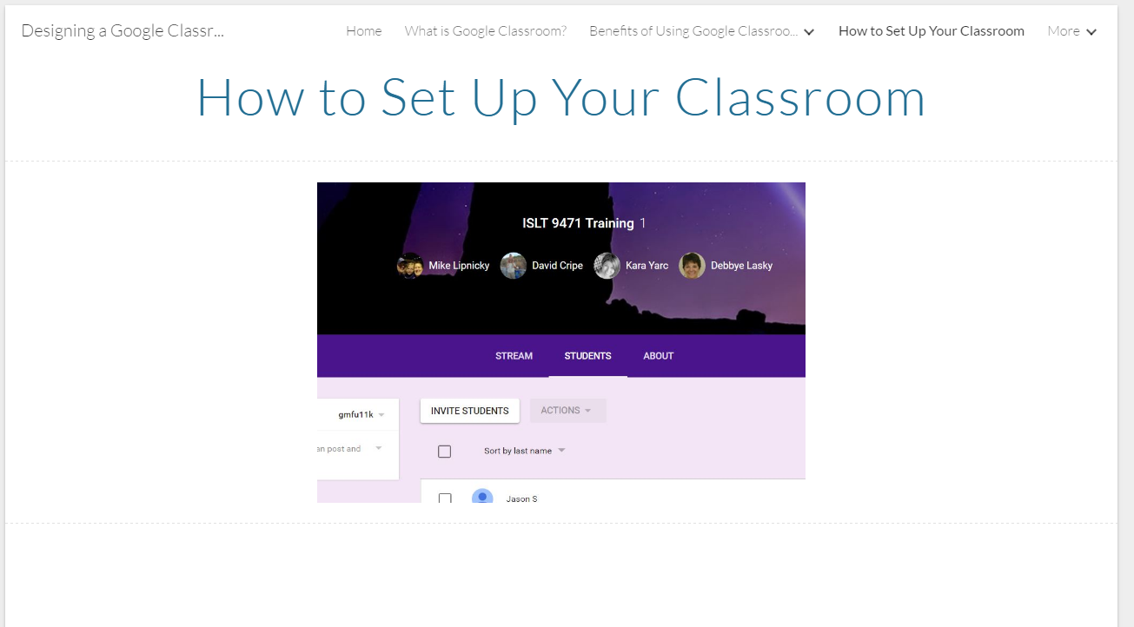

Implementation Plan
Sample Schedule for 1 day implementation with 1 Group*:

8:00 to 8:10 Complete Assessment Survey
8:15 to 9:15 Instruction Delivery 1
9:20 to 10:20 Lab Work
10:25 to 11:25 Instruction Delivery 2
11:30 to 12:30 Lab Work

*This schedule Sample has built in breaks between sessions that could be condensed depending on the facility used, and how much movement is required, also if the schedule needs further condensed it is recommended to pull time from the Lab work and not the Instructional Delivery.

